**Flight Gyro Controller**

**Project Plan-**

Most of us have experience with a flight remote controller. The concept we are going to build is same but the foundation and structure behind the project is completely new. Even the TECHGODS haven’t experienced it before.

So, the idea starts with a flight controller. Not the ordinary one but a controller which will have no joystick, no antenna, just two small so-called ‘Gyro Bars’ to have a grip. The controller will look like this.

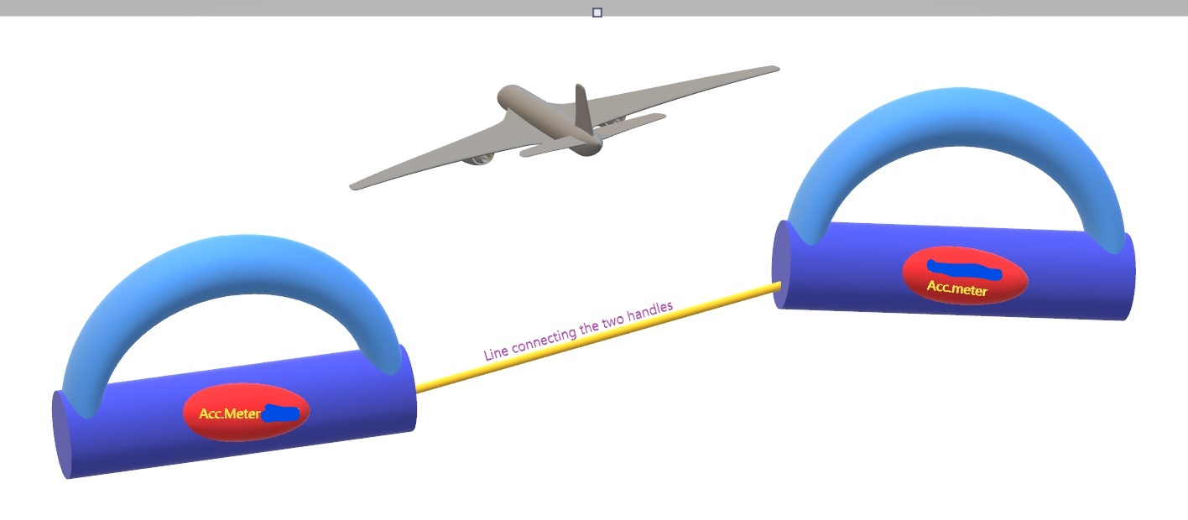

As you can see in this figure, the two Gyro Bars will contain all the parts that are the core materials behind the functioning of the controller. Moving or tilting any Gyro Bar will result in tilting of the imaginary line connecting the two bars, and so will the plane.

This will look very attractive, I guess!

This design will look quite awkward at the first sight, but we aim to improve it by working together and make this project happen successfully.

Rest of the plan will be discussed in the meet!

Talking about us,

Aditya Krishna Gupta, EEE branch, DH3.

Anupam Kumar, EEE branch, DH2.